# **SERVERLESS IOT PROCESSING**

PHASE 1 : **Problem Definition and Design Thinking**

**Problem Definition:**

The project aims to transform a home into a smart living space using IBM Cloud Functions for IoT data processing. The goal is to collect data from various smart devices, process it in real-time, and automate routines for energy efficiency and home security. This involves designing the smart home setup, implementing data collection and processing, and leveraging IBM Cloud for storage and analysis.

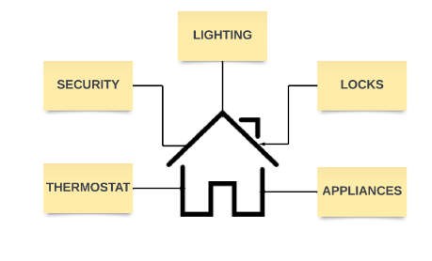

**OBJECTIVES :**

Transform a traditional home into a smart living space using IBM Cloud Functions for IoT data processing. The goal is to seamlessly integrate various smart devices, such as thermostats, motion sensors, and cameras, to enhance energy efficiency and home security. This involves designing the smart home setup, implementing real-time data processing, utilising IBM Cloud for data storage and analysis, ensuring data security, and providing user-friendly control options.

* **Data Integration**: Identify and integrate smart devices such as thermostats, motion sensors, and cameras into the smart home ecosystem.
* **Data Collection**: Set up data collection from these devices, utilising IoT protocols.
* **Real-time Processing**: Implement real-time data processing using IBM Cloud Functions.
* **Automation**: Develop automated routines for energy efficiency (e.g., adjusting thermostat settings) and home security (e.g., sending alerts on motion detection)
* **Storage and Analysis**: Store data in IBM Cloud Object Storage and analyse it to gain insights into energy consumption, security events, and patterns.

***Smart Home Transformation Using IBM Cloud Functions***

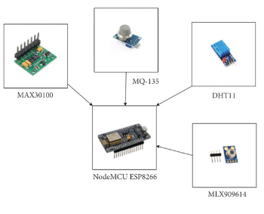

**1. Data Integration:**

This phase involves selecting compatible smart devices that align with the project's goals. Devices like thermostats, motion sensors, and cameras are chosen for their relevance to energy efficiency and home security. Integration ensures that these devices can communicate with each other and with the central control system.

**2. Data Collection:**

In this phase, the focus is on configuring data collection mechanisms from the integrated smart devices. IoT protocols, such as MQTT or HTTP, are employed to facilitate the transmission of data from these devices to the central data processing system. Data collection ensures that information is continuously gathered from the devices in the smart home ecosystem.

**3. Real-time Processing:**

Real-time data processing is a crucial step where IBM Cloud Functions come into play. These serverless functions are designed to analyse incoming data from the smart devices in real-time. This phase ensures that immediate actions and responses can be triggered based on the data generated by the devices.

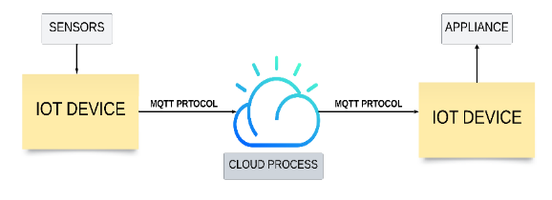

**4.Automation:**

Automation is key to achieving energy efficiency and home security goals. Automated routines are programmed to respond to specific events or conditions. For example, the system can automatically adjust thermostat settings when motion sensors detect occupancy or send security alerts when motion is detected outside predefined hours.

**5. Storage and Analysis:**

This phase involves storing historical IoT data securely in IBM Cloud Object Storage. Additionally, data analysis tools and services within the IBM Cloud ecosystem are utilised to extract valuable insights. These insights may include patterns of energy consumption, security events, and other trends that can inform further optimizations and decision-making within the smart home.

**6. Evaluate:**

*Measure success:* Use metrics and key performance indicators (KPIs) defined earlier to assess the impact of your serverless IoT data processing solution.

*Seek ongoing feedback*: Maintain open channels of communication with users and stakeholders to ensure the system remains aligned with their evolving needs.